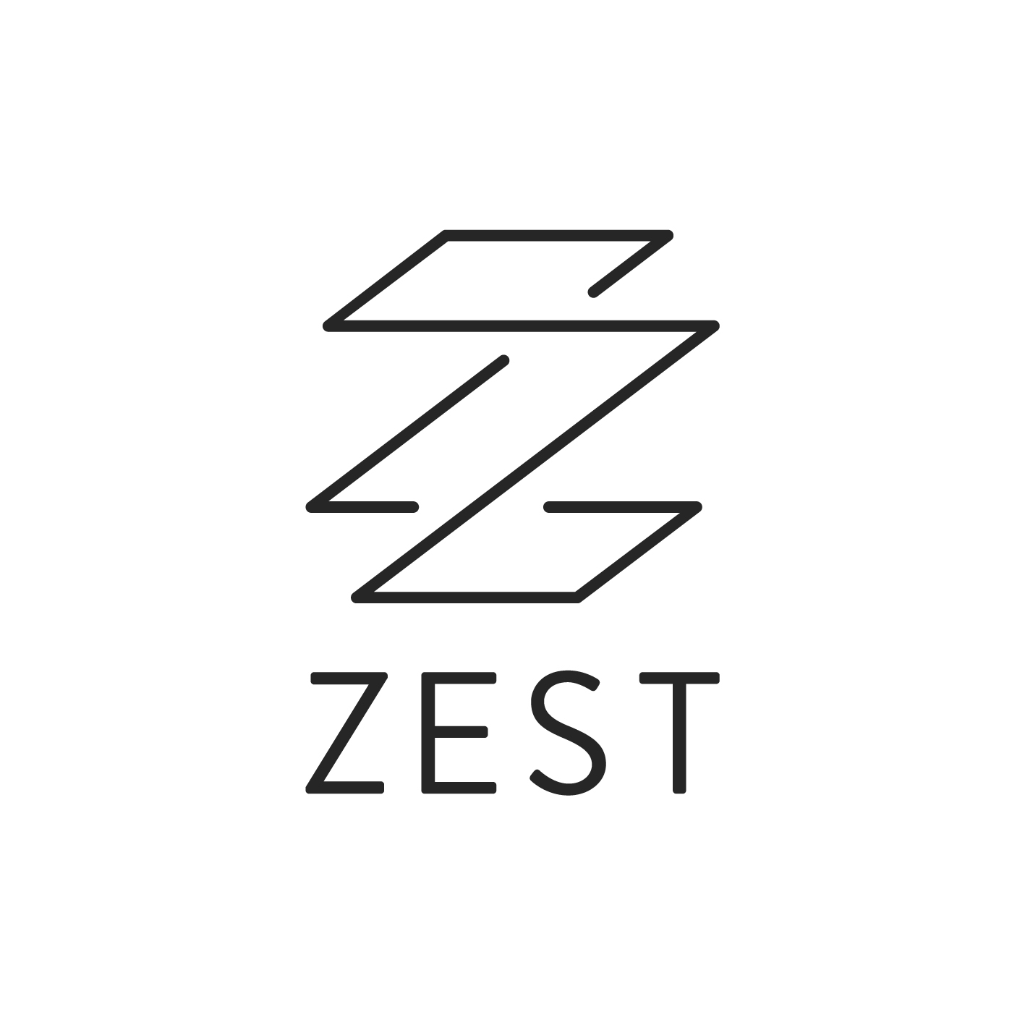
Application Form
PARTICIPATION COORDINATOR

Zest Theatre wants to make this application process open and accessible to all. If you feel you meet the requirements of the Job Description, we want you to apply.
This application form outlines all the key information we need to know as part of this recruitment process. How you respond is up to you: you can complete this form, or even submit a video or audio file of your responses. We are open to receiving your application in any format that best suits you and your access needs.

If you have any questions about submitting your application, please email jobs@zesttheatre.com

Personal Details

Surname Preferred title

First Name

Address

Telephone

Email

Pronouns e.g. She/her, He/Him, They/Them

I give consent for you to process my data* for the purpose of recruitment (please tick)
*See data protection statement below

Data Protection
We take your privacy very seriously: your personal information will be stored and processed by Zest Theatre in accordance with our Privacy Policy.

Zest Theatre will use the information you provide on this form for the purposes of recruitment for the role of Participation Coordinator only. We will destroy data relating to this recruitment process after 12 months unless you have been offered the role (in which case your application will be kept longer). If you have any questions about how we use your data you can ask by contacting us at hello@zesttheatre.com

Mailing List
We will not use this data to put you on our mailing list, or to contact you for anything other that the recruitment of this post. However if you would like to join our Mailing List you can do this on our website.

Referees
Please supply the names, full postal address and telephone numbers of two people who can give you a reference. At least one of these should be your current or most recent employer. Referees will not be contacted without your prior consent.

Name Name

Job Title Job Title

Address Address

Tel Tel

Email Email

ACCESS REQUIREMENTS
Please provide details below of any access requirements you would like to make us aware of (please note this will not affect your recruitment but will allow us to support your needs for attending interview if relevant).

VACANCY INFORMATION
How did you hear about this vacancy?

WORK EXPERIENCE – including relevant volunteering / internships:
You are welcome to list your Work Experience in the space below. Alternatively, you may attach a CV to your submission email, or send us a link to your website / LinkedIn.

DATE (to/from) | Organisation | Job title and key responsibilities | Reason for leaving

EDUCATION (please list most recent first):
Again, you are welcome to list your Education in the space below. Alternatively, you may attach a CV to your submission email, or send us a link to your website / LinkedIn.
DATE (to/from) | School/College/University | Qualifications gained (with grades)

Have you had any other relevant experience or training you’d like to tell us about?

What excites you most about joining Zest Theatre in this role? (250 words max):

With direct reference* to the job description and person specification, please tell us how your relevant skills and experience will enable you to fulfil this role at Zest Theatre.

*You can use the headings used on the Job Description or Person Spec to structure your answer if you find that helpful. However you choose to structure this, we recommend you refer to each key aspect of the role in your answer.

(No more than two A4 pages)

Complete our Equal Opportunities Monitoring Form that can be found HERE

Return your completed Application and Equal Opportunities Monitoring Form
Please submit both forms to jobs@zesttheatre.com with the email heading ‘Participation Coordinator’
Closing date: 12 noon 22nd May 2024

Interview dates: Thursday 30th or Friday 31st May 2024. All candidates will receive the interview questions in advance.

